Sierra Leone

## Respect for rule of law (ROL) data

The data set shows the data on the respect of the rule of law for the country.

## # A tibble: 19 x 5  
## country iso3c date ruleOfLaw ruleOfLawCategory4   
## <chr> <chr> <dbl> <dbl> <chr>   
## 1 Sierra Leone SLE 1996 -1.38 ROL highly disrespected   
## 2 Sierra Leone SLE 1998 -1.11 ROL highly disrespected   
## 3 Sierra Leone SLE 2000 -1.39 ROL highly disrespected   
## 4 Sierra Leone SLE 2002 -1.24 ROL highly disrespected   
## 5 Sierra Leone SLE 2003 -1.12 ROL highly disrespected   
## 6 Sierra Leone SLE 2004 -1.13 ROL highly disrespected   
## 7 Sierra Leone SLE 2005 -1.13 ROL highly disrespected   
## 8 Sierra Leone SLE 2006 -0.987 ROL moderately disrespected  
## 9 Sierra Leone SLE 2007 -0.988 ROL moderately disrespected  
## 10 Sierra Leone SLE 2008 -0.935 ROL moderately disrespected  
## 11 Sierra Leone SLE 2009 -0.901 ROL moderately disrespected  
## 12 Sierra Leone SLE 2010 -0.934 ROL moderately disrespected  
## 13 Sierra Leone SLE 2011 -0.854 ROL moderately disrespected  
## 14 Sierra Leone SLE 2012 -0.854 ROL moderately disrespected  
## 15 Sierra Leone SLE 2013 -0.859 ROL moderately disrespected  
## 16 Sierra Leone SLE 2014 -0.922 ROL moderately disrespected  
## 17 Sierra Leone SLE 2015 -0.854 ROL moderately disrespected  
## 18 Sierra Leone SLE 2016 -0.778 ROL moderately disrespected  
## 19 Sierra Leone SLE 2017 -0.786 ROL moderately disrespected

## Respect for rule of law (ROL) trend

The plot shows the trend of the respect for the rule of law for the country.

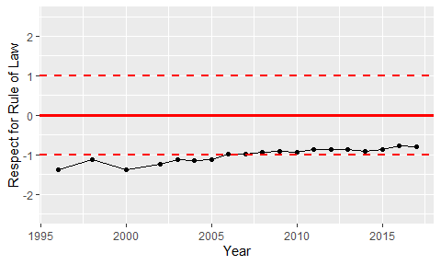

Trend of the Respect for the Rule of Law